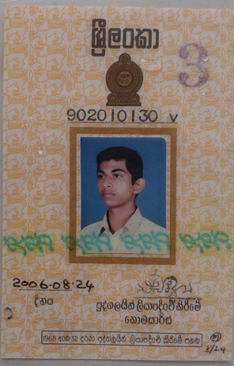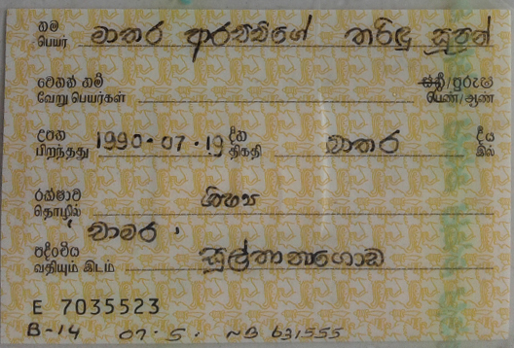



8994032300714382456

Name – Mathara Arachchige Tharindu Supun

Address – ‘Chamara’, Sulthanagoda.

Contact No : 071-9333595

Id no - 902010130v

5.5Gb Data Package.